LAB # 3
Introduction to Concurrency

OBJECTIVE: Understanding and implementing the concept of concurrency through different mechanisms of multithreading.

Lab Task:
1. Implement the following program on eclipse IDE and answer the following questions:
• How many threads are running?
• How many tasks are running?
• If more tasks are added than what will be the impact on number of threads?
• Explain the flow of program:
CODE:
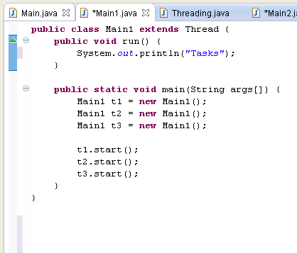

OUTPUT:

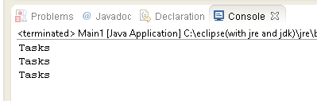

2. With the help of threading print two tables concurrently, print one table number of student roll number e.g. 2019-SE-092 and second number should be date of birth e.g. 05-April.
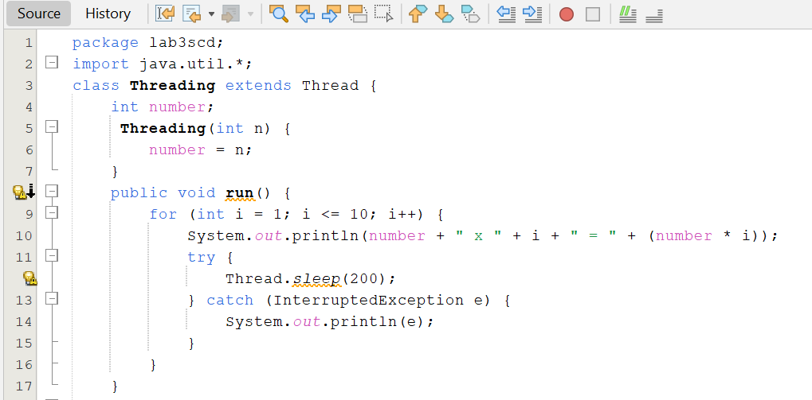
CODE:

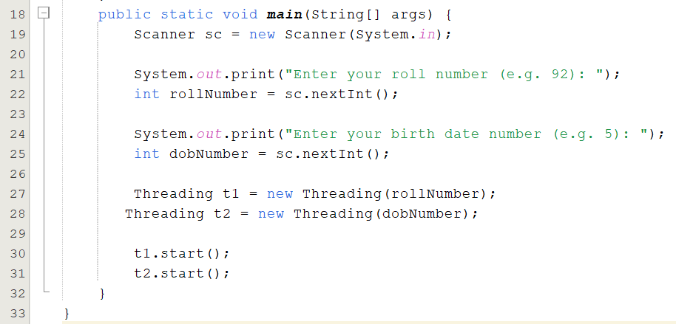

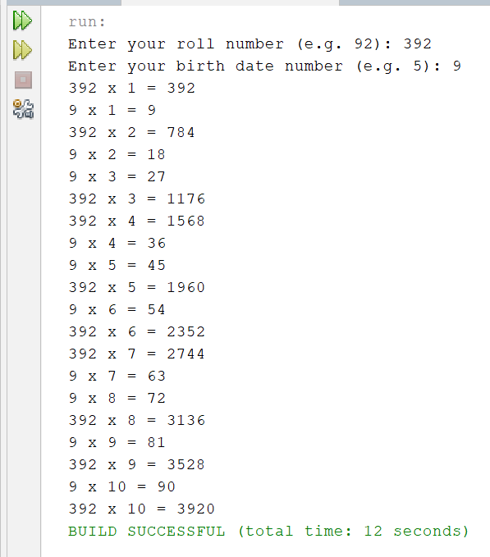
OUTPUT:

